National Honor Society

Induction Ceremony

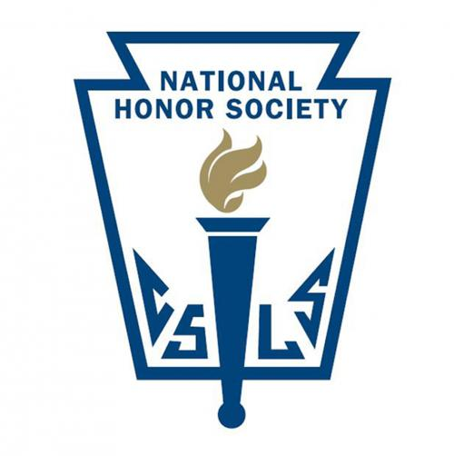

Ridgewood High School
Auditorium

Tuesday, April 5, 2022
7:00 p.m.

Induction Pledge

I pledge myself to uphold
the high purpose of
National Honor Society
to which I have been selected;
I will be loyal to my school;
And will maintain and encourage
high standards of
scholarship, service,
leadership, and character.



National Honor Society Officers

President Caylynn Bingham
Vice President Jacob Zoladz
Secretary Rosalia Maurello
Treasurer Jasmine Plaud
Advisor Ms. Pamela Mundy

Present Members
Patricia Adamczyk
Caylynn Bingham
Angela Borek
Bea DeGuzman
Sofia Didenko
Victoria Duszynski
Justyna Gromny
Emily Kinel
Julia Klusek
Katarina Krivokapic
Rose Lydon
Alana Manrique
Rosalia Maurello
Kiera O’Shea
Jasmine Plaud
Michelle Rivadeneira
Wafa Smairat
Jacob Zoladz

Processional
National Honor Society
Members and Inductees

Opening /Introduction of Present Members
Ms. Pamela Mundy

Candle Lighting Ceremony
Leadership Caylynn Bingham
Scholarship Jacob Zoladz
Character Rosalia Maurello
Service Jasmine Plaud

Induction of New Members
Ms. Pamela Mundy

Recessional
National Honor Society Members

Reception
Refreshments will be served in the student commons directly following the ceremony.


National Honor Society Inductees

Isabel Cabrera *
Ailyn Domalanta *
Hadeel Hussein *
JannaElyssa Laxamana *
Yaileen Michel *
Olivia Radziszewski *
Martina Vitale *
Alyssa Arnautovic
Emilia Bielska
Peter Bortis
Niamh Cannon
Julia Dalecki
Dalesska Felizzola
Eliska Horak
Nicholas Kalaras
Pamela Katsambas
Kevin Mimini
Clarisse Panlilio
Sofia Roman
Hailey Seggling
Jeremiah Serrano
Megan Spanola
Adrianna Vitale

* Denotes senior

